**Analyzing Tesla’s (TSLA) Yahoo!-Stock Price**

**20th September 2024**

**Were Vincent**

**Data Acquisition and Analysis**

* ***Stock Selection***

I chose Tesla (TSLA) for this analysis due to its significant impact on the electric vehicle market and the high volatility of its stock price. Tesla's innovative products and strong market presence have made it a focal point for investors, leading to substantial fluctuations in its stock value.

* ***Data Retrieval and Processing***

Using the tidyquant package in R, I downloaded daily stock price data for Tesla from January 1, 2023, to the present day from Yahoo! Finance data. The data was then exported to a CSV file for further analysis and reference (Wickham et al., 2023).

* ***The Code***

*# Install required packages*

*options(repos = c(CRAN = "https://lib.stat.cmu.edu/R/CRAN/"))*

*install.packages(c("tidyquant", "ggplot2")) # Just install if not available*

*# Load the packages*

*library(tidyquant)*

*library(ggplot2)*

*# Sets the ticker symbol and date range*

*ticker <- "TSLA"*

*start_date <- "2023-01-01"*

*end_date <- Sys.Date()*

*# Download daily price data using tidyquant*

*stock_data <- tq_get(ticker,*

*get = "stock.prices",*

*from = start_date,*

*to = end_date)*

*# Export data to CSV file*

*write.csv(stock_data, file = "C:\\Users\\n\\Downloads\\Tesla_Daily_Prices.csv")*

*# Create a basic plot of the closing price with different colors*

*ggplot(stock_data, aes(x = date, y = close)) +*

*geom_line(color = "blue") + # Change color here*

*labs(title = "Tesla (TSLA) Daily Closing Price",*

*x = "Date",*

*y = "Closing Price") +*

*theme_minimal() # Optional: improves the aesthetics*

* ***Visual Analysis***

The generated plot provides a visual representation of Tesla's stock price fluctuations over the specified period. Key observations includes;

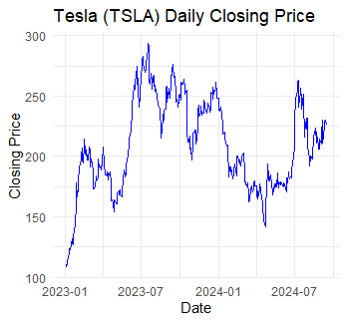

*Figure 1:A plot providing a visual representation of Tesla's stock price fluctuations over a specified period*

* *Volatility-* The stock price has exhibited significant volatility, with periods of rapid increases and decreases.
* *Trend-*While there have been periods of upward and downward trends, there is no clear, consistent direction (Wickham, 2016).
* *Price Fluctuations-* The price has experienced both large and small fluctuations, indicating potential market sentiment shifts.

**Conclusion**

This analysis provides a preliminary overview of Tesla's stock price behavior. Further analysis, including technical indicators and fundamental factors, would be necessary to gain a more comprehensive understanding of the stock's performance and potential future trends.

**References**

Wickham, H., François, R., Grolemund, A., & Ooms, J. (2023). Tidyquant: Tidy tools for quantitative finance. R package version 1.1.1. https://CRAN.R-project.org/package=tidyquant

Wickham, H. (2016). ggplot2: Elegant graphics for data analysis. Springer. https://ggplot2-book.org/

R Core Team (2023). R: A language and environment for statistical computing. R Foundation for Statistical Computing. https://www.R-project.org/